I’m wondering if we should add a box here

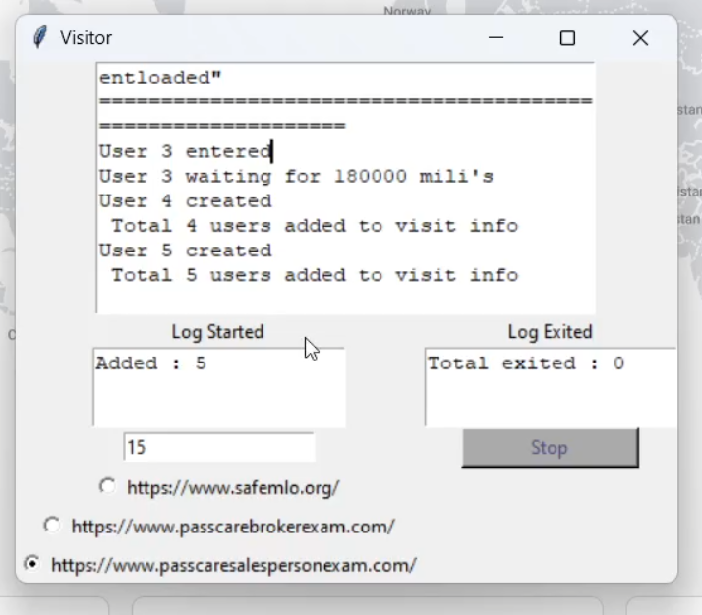

that shows the IP address being used in real time for each User.

Or this can be shown in the large VISITOR box under the User.

User 3 entered

IP: 134.73.98.130

User 4 entered

IP: 66.78.34.94

Also, what happens if an IP is bad and it doesn’t work? Will it skip it and go to the next one?

What are these numbers?

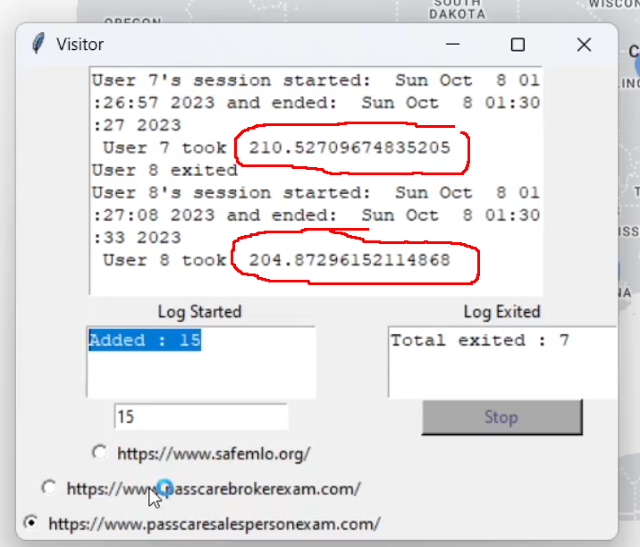

Yes, I 100% agree with this 10~30 sec delay. I think it more represents a real life situation. KEEP IT IN!

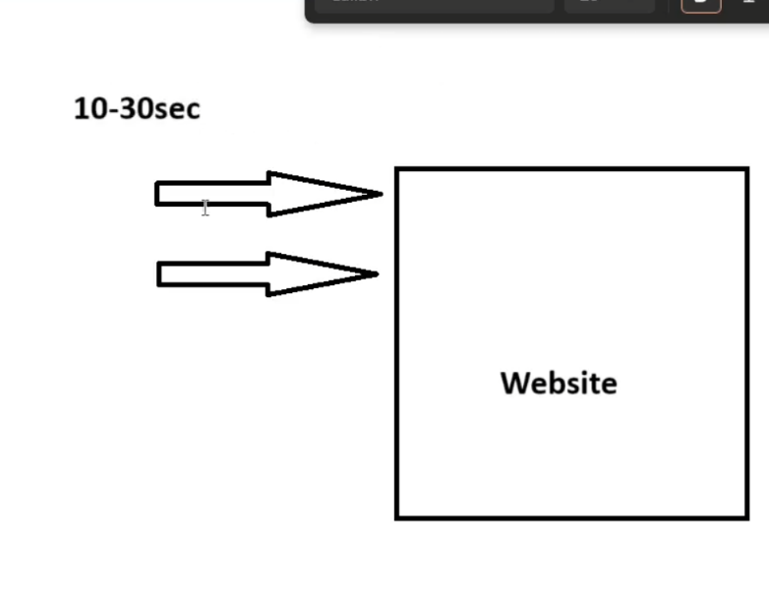

Is it possible to be able to add my own website address here in case I want to add another one later or is this not possible because it can only hit the landing page and not go to the 2nd page.

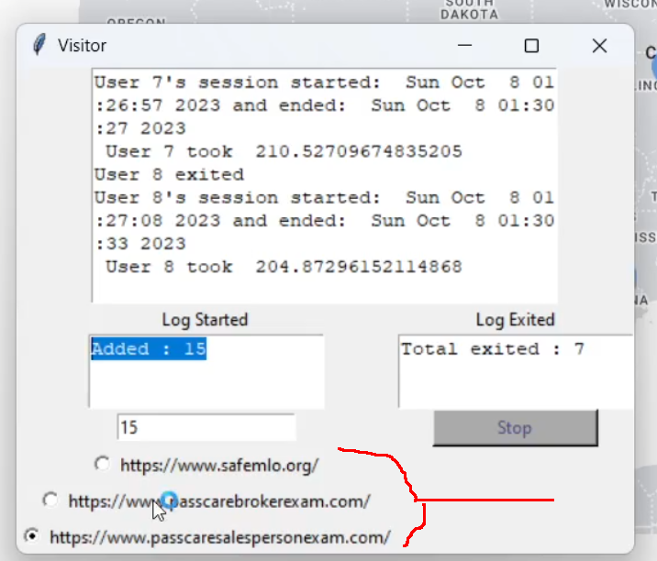

So how many can I safely send to each website in a day?